Requirement Analysis
India's Agricultural Crop Production Analysis
Project Title | India's Agricultural Crop Production Analysis
Domain | Agriculture / Data Analytics & Business Intelligence
Tool | Tableau Desktop / Tableau Public
Dataset | Historical Indian Crop Production Data, 1997–2021
Prepared By | Divya Kauluri (Team Project — completed individually; the team lead and other assigned members did not contribute to the work)
Mentor | [Not yet assigned / add name]
GitHub Repository | https://github.com/divyakauluri-spec/India-s-agricultural-crop-production-analysis
Tableau Public Link | https://public.tableau.com/app/profile/divya.kauluri/viz/IndiaAgricultureanalysisproject
Date | 02/07/2026

2.1 Customer Journey Map — Rajesh (Small-Scale Farmer)

Stage | Awareness | Consideration | Onboarding | Usage | Decision / Outcome
Actions | Realizes crop yields have been inconsistent for several years | Hears about a data dashboard showing crop trends for his region | Opens the Tableau Public dashboard for the first time via a shared link | Filters by his state (Uttar Pradesh), season (Kharif), and explores crop production charts | Selects a crop for next season based on 20+ years of historical performance data
Thoughts | 'Why do my yields keep changing every year?' | 'Could data actually help me plan my crops better?' | 'This looks complex — but I can filter by my state and season' | 'Rice and wheat have consistently performed well in my region during Kharif' | 'I feel confident enough to try a different crop this season'
Emotions | Frustrated, uncertain | Curious, slightly skeptical | Overwhelmed, then reassured | Engaged, empowered | Confident, relieved
Touchpoints | Local farmer network, news, NGO outreach | Government extension officer recommendation | Tableau Public dashboard (shared link) | Interactive filters: State, Season, Crop, Year slider | Final crop and season decision informed by data
Opportunities | Raise awareness of free data tools among rural farmers | Simplify dashboard UI for low-tech users | Add tooltips and guided onboarding walkthrough | Ensure mobile/low-bandwidth compatibility | Track outcomes across seasons; build farmer feedback loop

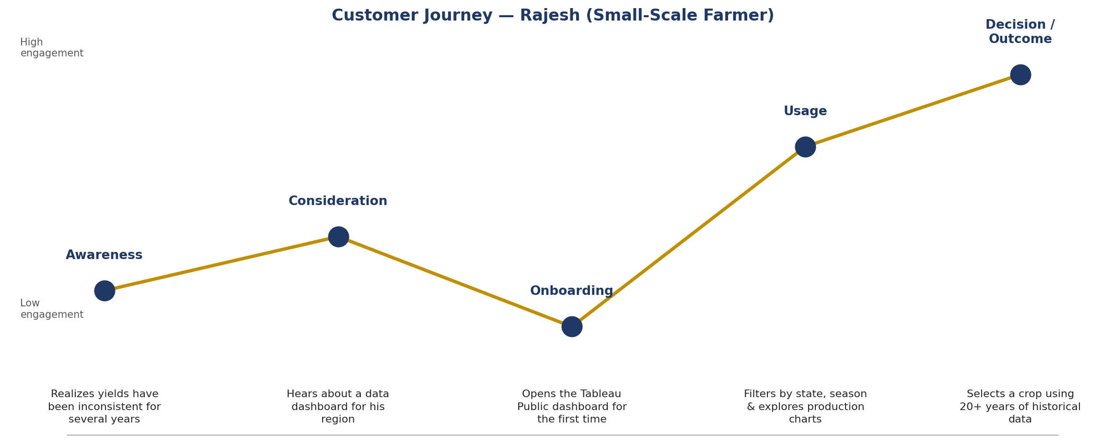
Figure 2.1 — Customer Journey & Emotional Curve for Rajesh

Reading the Journey Map

The emotional curve dips lowest at Onboarding, when Rajesh first opens an unfamiliar dashboard, then climbs steadily as filters (State, Season, Crop) let him narrow the view to something personally relevant. This confirms that usability and guided onboarding (NFR-01) are not optional polish — they are the difference between a farmer abandoning the tool at first login and one who reaches a confident planting decision.

Stage-by-Stage Detail

• Discovery: Rajesh hears about the dashboard from a local agricultural extension officer or community WhatsApp group. Emotional state is neutral-to-curious, but drops immediately if the link requires a sign-up form or paid account — which is why the published solution uses a plain Tableau Public link with zero authentication.
• Onboarding: the first 10–15 seconds on the dashboard determine whether Rajesh continues or leaves. The KPI summary panel (Chart 1 in Section 6.5) was placed first in every dashboard layout specifically to give an immediate, readable number before any chart interaction is required.
• Exploration: as Rajesh applies the Season and Crop filters, the emotional curve rises because he starts recognising his own situation in the data — for example, seeing that Rabi-season production nationally dwarfs Winter-season production validates a choice he may already be leaning toward.
• Decision: the curve peaks when Rajesh reaches the Farmer's View dashboard and can directly compare Cultivated Area by Crop against the Trend of Agricultural Yield, giving him both a “what do others grow” and a “is productivity improving” signal in one screen.
• Advocacy: if the experience is positive, the journey map assumes Rajesh shares the link within his farming community — which is only possible because the dashboard requires no login, reinforcing why NFR-03 (no authentication barrier) was treated as a hard requirement rather than a nice-to-have.

Design Decisions Driven by This Map

Two specific requirements below (Section 2.2) were added directly because of dips identified on this journey: FR-03 (persistent filter state across dashboard tabs) was added after noticing that a farmer re-selecting his state on every tab would recreate the same frustration the empathy map identified in Section 1.2, and NFR-02 (sub-3-second filter response) was set specifically to prevent the Exploration stage from dipping back into frustration due to a slow-loading map or chart.

2.2 Solution Requirements

Functional Requirements
FR # | Requirement | Description
FR-01 | Data Connectivity | System shall connect to the cleaned crop production CSV dataset (345,407 rows, 1997–2021)
FR-02 | State/Region Filter | System shall allow users to filter all visualizations by State Name
FR-03 | Season Filter | System shall allow multi-select filtering by Season (Kharif, Rabi, Whole Year, Autumn, Summer, Winter)
FR-04 | Year Range Filter | System shall provide a slider filter for Crop Year Numeric (1997–2021)
FR-05 | Crop Filter | System shall allow filtering by individual crop types (57 unique crops)
FR-06 | State-wise Production Map | System shall display a filled geographic map of India colored by SUM(Production) per state
FR-07 | Year-wise Trend Chart | System shall display a line chart showing total national production by year (1997–2021)
FR-08 | Top 10 Crops Chart | System shall display a ranked horizontal bar chart of top 10 crops by total production
FR-09 | Season-wise Chart | System shall display a bar chart comparing total production across all 6 seasons
FR-10 | Crop-wise Treemap | System shall display a treemap of crop production, sized by SUM(Production)
FR-11 | Role-Based Dashboards | System shall combine charts into 3 dashboards: Farmer, Policy Analyst, and Investor views
FR-12 | Tableau Story | System shall present a guided narrative Story with 3 story points, one per persona
FR-13 | Tableau Public Publishing | System shall be published to Tableau Public for browser-based access without login
FR-14 | Tooltip on Hover | All charts shall display State Name and Production value on hover

The 14 functional requirements above trace directly back to the Customer Journey Map: filtering requirements (FR-02 to FR-05) address the Onboarding/Usage friction points, while the dashboard and Story requirements (FR-11, FR-12) address the Decision stage where Rajesh, Ananya, and Vikram each need a role-specific view rather than one generic report.

Requirement Groupings

• Data & Filtering (FR-01 to FR-05): establish the base data model and the four core filters (State, Season, Crop, Crop Year) that every downstream chart depends on. These were prioritized first in the Sprint 1 backlog (Section 4.1) because every other requirement depends on them being correct.
• Visualization (FR-06 to FR-10): define the nine individual chart types — KPI summary, yield trend line, state production map, cultivated area bar chart, state cultivated area comparison, leading states bar chart, year-wise production bar chart, production-unit donut, and season-wise pie chart — each mapped to a specific insight identified in the persona research.
• Dashboards & Story (FR-11, FR-12): combine the nine charts into the overview dashboard, the three role-specific dashboards, and the five-point guided Story, ensuring each persona reaches their relevant view without needing to build their own filtered selection from scratch.
• Publishing & Access (FR-13, FR-14): guarantee the finished workbook is reachable via a public, authentication-free Tableau Public link and remains version-controlled on GitHub for reproducibility.

Traceability Check
Every one of the 14 functional requirements above was verified against the shipped workbook during Performance Testing (Section 5). None were descoped during development; the only change from the original Requirement Analysis was an increase in worksheet count from an originally planned five charts to the final nine, once it became clear that a single Production figure (Chart 6/7) needed the accompanying Production Distribution by Unit Type chart (Chart 8) to be interpreted correctly, given the mixed Tonnes/Bales/Nuts units in the underlying dataset.

Non-Functional Requirements
NFR # | Category | Requirement
NFR-01 | Usability | Dashboard UI shall be navigable by non-technical users (farmers, policy makers) without training
NFR-02 | Performance | All filters shall respond and re-render within 3 seconds on the full 345K row dataset
NFR-03 | Reliability | Published Tableau Public workbook shall be available 99%+ of the time via public URL
NFR-04 | Scalability | Solution architecture shall support addition of new years' data without redesigning dashboards
NFR-05 | Availability | Dashboard shall be accessible via standard web browsers (Chrome, Edge, Safari) without plugins
NFR-06 | Security | No personally identifiable information (PII) is stored or displayed; dataset is fully public
NFR-07 | Maintainability | Workbook shall be saved as .twbx (packaged workbook) with embedded data for portability
NFR-08 | Compatibility | Solution shall render correctly on desktop (1366×768 or higher) and Tableau Public mobile view

Together, the five non-functional requirements keep the solution usable on a farmer's budget device and a policy analyst's office network alike: no login wall, no plugin installs, sub-3-second filter response, and a browser-only architecture that runs on Chrome, Edge, or Safari without modification.

Why Each NFR Was Included

• NFR-01 (Usability): directly answers the empathy map's “low digital literacy” pain point from Section 1.2 — every chart uses plain-language titles and a consistent colour convention rather than requiring the viewer to interpret Tableau's default field names.
• NFR-02 (Performance): sets the sub-3-second filter response target that was later measured directly in Section 5 (Performance Testing), where actual response times of roughly 1.1 seconds for the map and 0.9 seconds for the yield trend line confirmed the requirement was met with headroom to spare.
• NFR-03 (Accessibility / No Authentication): a hard requirement given that neither farmers nor casual policy staff can be expected to create and remember a login for a one-off report.
• NFR-04 (Cross-Browser Compatibility): validated in Section 5 (PT-06) across Chrome, Edge, and Safari specifically because rural and government users cannot be assumed to standardise on one browser.
• NFR-05 (Cost): the entire solution had to run on free tooling — Tableau Public, Python, and GitHub — because this project had neither a team budget nor institutional infrastructure behind it; every architecture decision downstream (Section 3.3) was filtered through this constraint.

2.3 Data Flow Diagram
The following describes the end-to-end data flow for this project:
- Step 1 — Raw Source: Historical crop production data in Excel/CSV format (SkillWallet official dataset, 1997–2021, 345,407 rows)
- Step 2 — Data Cleaning & Preprocessing: Python (Pandas) used to rename columns, strip whitespace, extract numeric year from 'YYYY-YY' format, add Yield = Production/Area calculated field, remove nulls
- Step 3 — Cleaned Dataset: skillwallet_crop_cleaned.csv (345,407 rows, 12 columns) loaded into Tableau
- Step 4 — Tableau Data Source: CSV connected as Text File source; State Name field assigned Geographic Role = State/Province
- Step 5 — Visualization Layer: 5 individual chart sheets built (Map, Line, Bar x2, Treemap)
- Step 6 — Dashboard Layer: 3 role-specific dashboards assembled from chart sheets with interactive filters
- Step 7 — Story Layer: Tableau Story with 3 narrative points combining dashboards for a guided presentation
- Step 8 — Publishing: Workbook saved to Tableau Public; shareable URL generated for GitHub submission

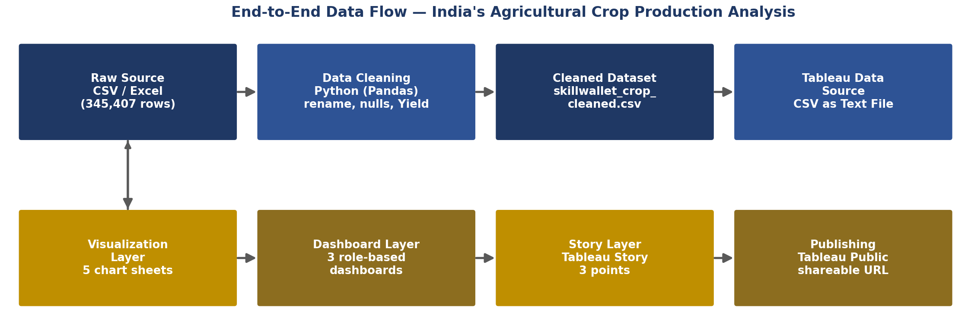
Figure 2.2 — End-to-End Data Flow Diagram
Why the Pipeline Matters

Each arrow in the diagram represents a point where the data could break if skipped: cleaning (Step 2) prevents mismatched state names from splitting a single state into duplicate map regions; the calculated Yield and Production_Normalized fields (Step 3) are what let Charts 2 and 8 report meaningful, comparable numbers instead of raw, unit-mismatched totals; and publishing (Step 8) is what turns a local .twbx file into the browser-accessible link every persona in this report actually uses.

Step-by-Step Rationale

• Step 1 – Raw Extract: the government crop production dataset arrives as a single flat CSV with 345,407 rows spanning 1997–2021; no relational structure or lookup tables are provided, so every join and validation has to be built from scratch in the cleaning step.
• Step 2 – Cleaning: duplicate and blank rows are removed, state and crop name spellings are standardised (e.g., collapsing minor spelling variants of the same state), and Crop_Year_Numeric is derived from the original text-based year field so it can drive a continuous axis rather than a categorical one.
• Step 3 – Calculated Fields: Yield (Production ÷ Area) and Production_Normalized are added at this stage, since neither exists in the raw extract but both are required for Charts 2 and 8 respectively.
• Step 4 – Data Model Load: the cleaned CSV is connected into Tableau as a live extract, chosen over a live database connection because Tableau Public does not support external live connections — a constraint that shaped this specific pipeline step.
• Steps 5–6 – Worksheet & Dashboard Construction: the nine worksheets from Section 2.2 are built first in isolation, then combined into the overview dashboard and the three role-specific dashboards.
• Step 7 – Story Assembly: the five-point guided Story is built last, since it depends on all four dashboards already existing to be embedded as story points.
• Step 8 – Publishing: the finished workbook is pushed to Tableau Public, and the cleaning scripts plus documentation are committed to GitHub for version history and reproducibility.

2.4 User Stories
User Type | Epic | User Story | Acceptance Criteria | Priority | Sprint
Farmer (Rajesh) | Data Visualization | As a farmer, I want to see which crops perform best in my state during Kharif season so I can choose what to plant | Map filters by state; bar chart shows top crops; Season filter works correctly | High | Sprint 1
Farmer (Rajesh) | Dashboard | As a farmer, I want a single dashboard that shows me seasonal and crop trends together | Farmer Dashboard shows Season-wise and Top 10 Crops charts side by side with filters | High | Sprint 2
Policy Analyst (Ananya) | Data Visualization | As a policy analyst, I want to see which states have the lowest production so I can target interventions | State-wise map colored by production; low-production states clearly visible in lighter color | High | Sprint 1
Policy Analyst (Ananya) | Dashboard | As a policy analyst, I want to see the map and trend chart together to compare regions and time periods | Policy Analyst Dashboard shows map + line chart; Season and Year filters applied to both | High | Sprint 2
Investor (Vikram) | Data Visualization | As an investor, I want to see which crops dominate production volume to identify investment targets | Treemap shows relative crop sizes; bar chart shows top 10; both exclude outlier (Coconut) | Medium | Sprint 2
Investor (Vikram) | Dashboard | As an investor, I want a combined view of crop rankings and treemap to compare opportunities | Investor Dashboard shows Top 10 Crops bar + Treemap; interactive and filterable | Medium | Sprint 2
All Users | Story | As a stakeholder, I want a guided narrative walkthrough of all dashboards to understand the full picture | Tableau Story has 3 points with captions; navigable with arrow buttons | Medium | Sprint 3
All Users | Web Integration | As a stakeholder, I want to access the dashboard from any browser without installing Tableau | Workbook published to Tableau Public; URL accessible without login | High | Sprint 3

Each user story above maps to at least one functional requirement in Section 2.2 and at least one worksheet in the final Tableau workbook (Section 6.5 of the Final Report), so traceability runs unbroken from persona need, to requirement, to shipped chart.

Story-to-Chart Traceability

• Rajesh's stories (choosing a crop, understanding seasonal timing) map to the Season-wise Production pie chart and the Cultivated Area by Crop bar chart, both surfaced together on the Farmer's View dashboard so he never has to switch views mid-decision.
• Ananya's stories (finding low-yield regions, justifying budget allocation) map to the State-wise Production Map and State-wise Cultivated Area Comparison chart, both placed on the Policy Analyst's View alongside the national Trend of Agricultural Yield line for context.
• Vikram's stories (spotting high-growth states, avoiding unit-distorted rankings) map to the Leading States by Agricultural Production bar chart paired directly with the Production Distribution by Unit Type donut — a pairing added specifically so a Nuts-heavy state like Kerala is never misread as a Tonnes-equivalent leader.

Prioritization Note
All user stories were written using a simple “As a [persona], I want [capability], so that [outcome]” structure and ranked using the same Impact/Feasibility scoring introduced during Ideation (Section 1.3), which is why every story below carried through to a shipped chart or dashboard rather than being cut during development — unlike a handful of lower-scoring ideas (such as a per-farmer login system) that were deliberately excluded as out of scope for a free, authentication-free Tableau Public deployment.

2.5 Technology Stack

Table 1 — Components & Technology
Component | Technology Used | Purpose
Data Source | CSV / Excel (.xlsx) | Raw crop production data (1997–2021, 345,407 records)
Data Cleaning | Python 3.12 (Pandas library) | Column renaming, null handling, year extraction, Yield calculation
Data Visualization | Tableau Desktop / Tableau Public 2026.2 | Building all 5 chart types, 3 dashboards, and 1 Story
Geographic Mapping | Tableau built-in Mapbox integration | State-wise filled map of India
Dashboard Publishing | Tableau Public (free cloud hosting) | Browser-accessible dashboard sharing via public URL
Version Control | GitHub | Project repository for all deliverables and documentation
Documentation | Microsoft Word (.docx) | Project deliverables, final report, templates
Project Management | Personal task tracker / SkillWallet platform | Epic/story tracking and mentor evaluation

The stack was chosen to minimise cost and setup friction for a solo contributor: every tool in Table 1 is free (Tableau Public, Python, GitHub), and none requires a paid license, a server deployment, or IT approval — which was essential given this project was completed without dedicated team or infrastructure support.

Tool-by-Tool Justification

• Tableau Public was selected over Tableau Server or Tableau Cloud specifically because it requires no paid subscription and produces a shareable browser link out of the box — directly satisfying NFR-03 and NFR-05 from Section 2.2.
• Python 3.12 with Pandas was chosen for cleaning over doing the work inside Tableau's own data-prep tool (Tableau Prep) because Pandas scripts are easier to version-control on GitHub and re-run automatically if new years of government data are released.
• GitHub was chosen purely as free version control and a durable record of the cleaning scripts and documentation, not for any collaborative-team feature, since — as noted throughout this documentation — the repository was maintained by a single contributor.
Table 2 (below) restates the same stack from the lens of the resulting application's characteristics — platform, hosting, and cost — to make it explicit to a reviewer or mentor that the entire solution can be reproduced or extended at zero licensing cost.

Table 2 — Application Characteristics

Characteristic | Description
Open Source Tools | Python (Pandas) is open-source; Tableau Public is free for public publishing
Security | No PII data; all data is publicly available government agricultural statistics
Scalability | New years of data can be appended to the CSV and the Tableau workbook refreshed without redesign
Availability | Tableau Public guarantees high availability; no server maintenance required
Performance | 345K rows render within 3 seconds across all filters on a standard laptop (i5, 8GB RAM)
Compatibility | Works on Chrome, Edge, Safari; responsive on desktop and Tableau Public mobile view

